For the sake of simplicity, here are the notation I’m using for this report.

u0 = initial prior mean

sig0 = initial prior variance

u = likelihood mean

sig = likelihood variance

1. Prior mean initialized to correct value vs wrong value.

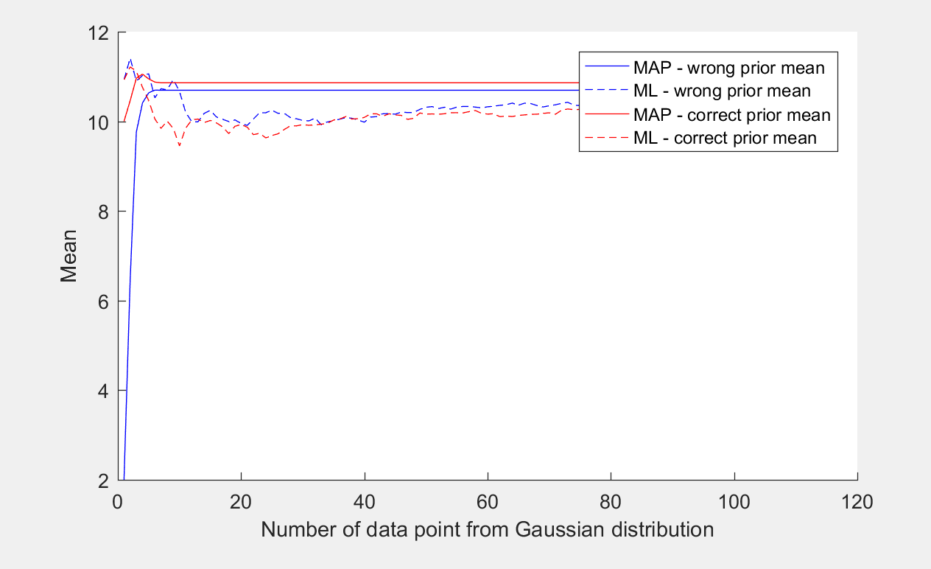

Initialization values are the following. U0 was initialized to 10 and 2 to demonstrate the “correct” and “wrong” values.

u0 = (correct – 10), (wrong – 2)

sig0 = 2

u = 10

sign = 10

Even though u0 was initialized to the wrong value, the ML solution was able to start with values

2.